**AMERICAN INTERNATIONAL UNIVERSITY BANGLADESH (AIUB)**

**FACULTY OF SCIENCE & TECHNOLOGY**

Course Title

**INTRODUCTION TO DATABASE (CSC2108)**

**Semester:   
Section: [ T]**

**TITLE**

**ISP Management System**

**Supervised By**

**Md. Sazid Uddin**

**Submitted By: Group no: 01**

|  |  |
| --- | --- |
| **Name** | **ID** |
| Rofiqullah Munna | 23-*-3 |
| Abdullah Al Nahian | 23-*-3 |
| Raisa Chowdhury | 23-*-3 |
| Mst. Fabiha Afifa | 23-*-3 |

**TABLE OF CONTENTS**

|  |  |  |
| --- | --- | --- |
| **TOPICS** | | **Page no.** |
| **Title Page** | | **1** |
| **Table of Content** | | **2** |
| **1.** | **Introduction** | **3** |
| **2.** | **Case Study** | **4** |
| **3.** | **ER Diagram** | **5** |
| **4.** | **Normalization** | **6-13** |
| **5.** | **Finalization** | **14-15** |
| **6.** | **Table Creation** | **16-29** |
| **7.** | **Data Insertion** | **30-42** |
| **8.** | **Query Test** | **43-57** |
| **9.** | **DB connection** | **58-63** |
|  |  |  |
|  |  |  |

# **Introduction**

In today’s interconnected world, managing internet service provisioning has become increasingly complex. Our project focuses on developing an Internet Service Provider (ISP) Management System designed to provide a comprehensive and efficient solution for overseeing ISP operations. This system aims to streamline the processes of managing customer subscriptions, billing, bandwidth allocation, complaint handling, and service upgrades through a centralized platform. By implementing this project, ISPs can achieve enhanced operational efficiency, deliver seamless service experiences, and provide improved user satisfaction for both customers and service providers.

# **Case Study / Scenario**

There is an Internet Service Provider (ISP) named ‘Vanguard Connection’. In this ISP Management System, Customer need to have subscription. One customer can have multiple subscriptions. A customer is identified by Customer ID. The system also stores customer name, address, phone number, e-mail, and account status. Address are composed of city and country. Subscription have Subscription ID , start date, end date, status. Each subscription is associated with one service. Service can identified by Service ID, service type, monthly cost, service name which is composed by broadband, fibers and IPTV. A customer can make multiple payments. Payments has payment ID, payment date, amount , payment method. A customer can complain multiple times in problem box. Problem box identified by Problem ID, complain date, solve date, problem status. A problem box can have multiple task assigned to employees. Task has task ID. Task description and task status. A task is assigned to one employee. Employee has employee ID, name, phone number, email and role.

# **ER Diagram**

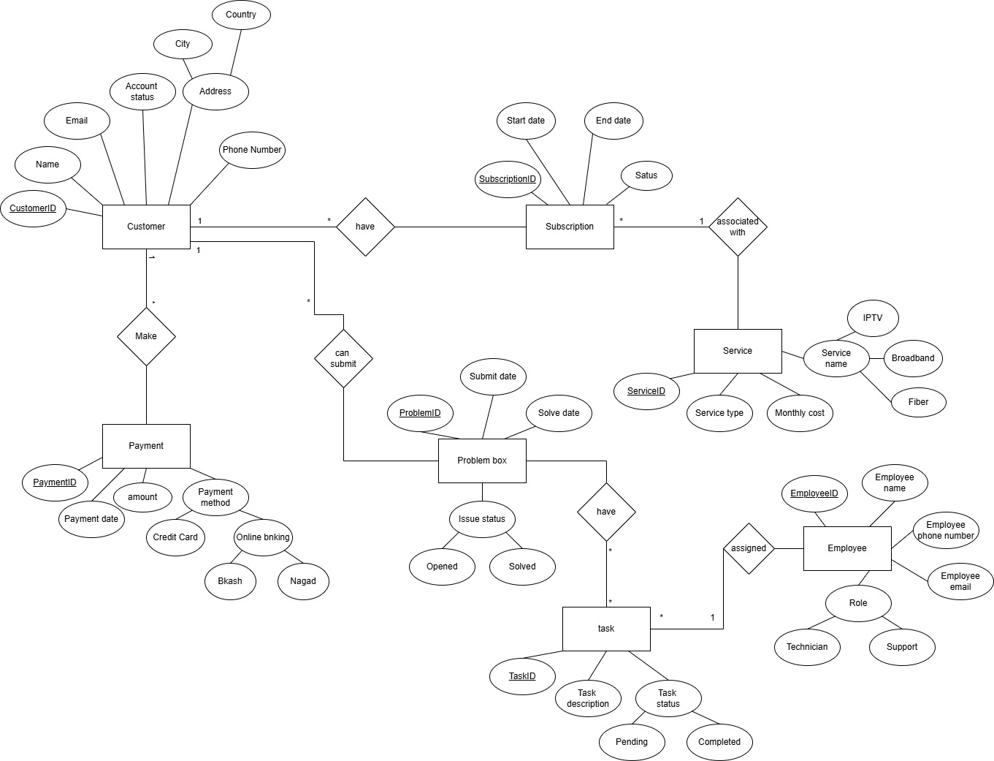

**Fig-1: ER Diagram for Internet Service Management (ISP) System**

# **Normalization**

**Fig-2: ER Diagram for Customer-have-Subscription**

Relationship: one to many

**UNF:** Customer ID,c_Name, c_Email, Account status, City,country, c_phone number, subscription ID,start date, End date, status.

**1NF:** Customer ID, c_phone number, c_Name, c_Email, Account status, City, Country, subscription ID, start Date, End-date, Status.

**2NF:** 1. Customer ID, c_Name, city, country.

2. Customer ID, c_phone number, account status, c_Email.

3. subscription ID , start date, status.

4. subscription ID , End date.

5. customer ID, subscription ID.

**3NF:** 1. Customer ID, c_Name,

2. City, Country

3. Customer ID, c_phone number , account status, c_Email.

4. subscription ID , start date, status.

5. customer ID, subscription ID.

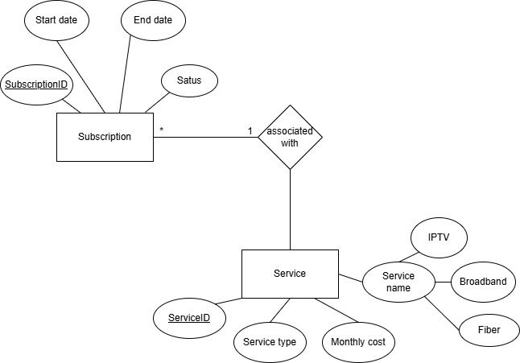

**Fig-3: ER Diagram for Subscription-associated with-Service**

**Relation**: Many to one

**UNF 1 :** Subscription-ID , Startdate , End date, status, Service ID, Broadband, Fiber, IPTV, Service type, monthly cost.

**1NF 1:** Subscription-ID , Start date, End date, status.

2: Service-ID, Broadband, Fiber. IPTV, monthly cost.

3: Subscription- ID, Service - ID , Service type.

**2NF 1:** Subscription- ID , Start date

**2**: service-ID, Broadband, Fiber, IPTV, monthly cost.

**3.** Subscription- ID, status.

**4.** Subscription-ID, Service-ID, Service.

**5.** Subscription-ID , End-date.

**3NF 1.** Subscription-ID , start date, end date.

**2.** Subscription-ID , status.

**3.** Subscription-ID, Service-ID .

**4.** service ID , monthly cost , service type.

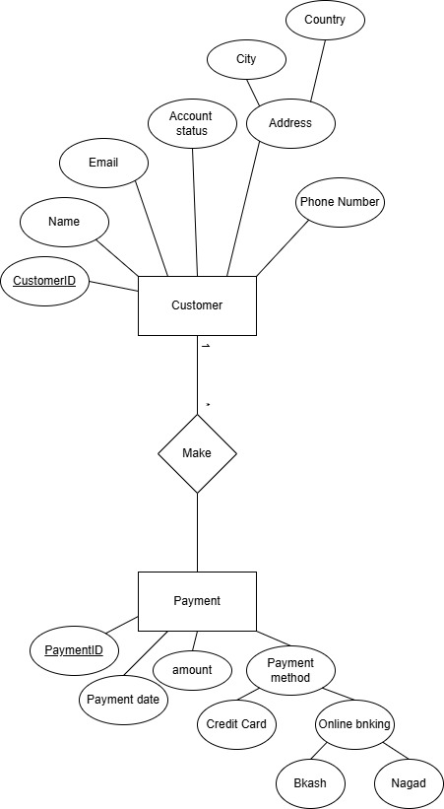

**Fig-3: ER Diagram for Customer-make-Payment**

**Relation:** one to many

**UNF: 1.** Customer-ID,C_Name, City, Country, CEmail, Account status, C_phone number, Payment-ID. Payment date, Amount, Credit Card, Bkash, Nagad.

**1NF 1.** Customer-ID , C_Phone number, C_Email.

**2.** Customer-ID, Payment-ID .

**3.** Payment-ID, Payment date, Amount, C_ Name, City, Country.

**4.** Payment-ID , Credit card, Bkash, Nagad.

**2NF 1.** Customer-ID, C_Phone number.

**2.** Customer-ID , Payment-ID, CEmail.

**3.** Payment-ID, Payment date, Amount, C_name, City,Country .

**4.** Payment-ID, Credit Card. Bkash, Nagad.

**3NF 1.** Customer-ID, C_Phone number .

**2.** Customer-ID, Payment-ID, C_Email.

**3.** Payment-ID, Payment date, C_Name, Amount.

**4.** City , Country.

**5.** Payment-ID, credit Card.

**Fig-4: ER Diagram for Customer-can submit problem-Problem box**

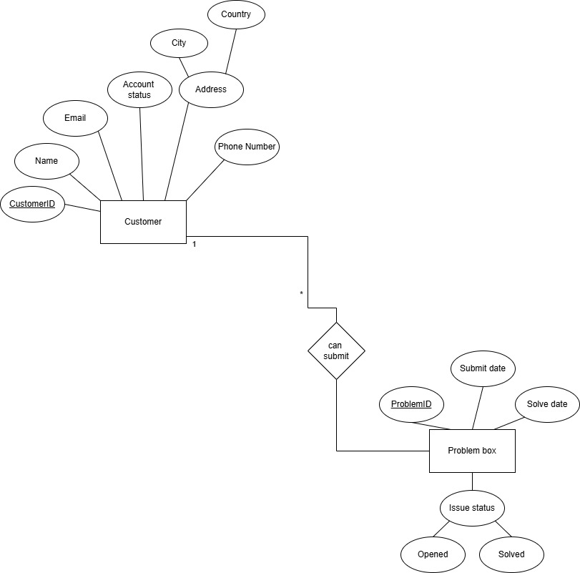**Relation:** one to many

**UNF: 1.**  Customer-ID, CName: City, country, C_phone number, C_Email, Account status, Problem-ID, Submit date, Solve date, Opened , Solved.

**1NF:** **1.** Customer-ID, CName, city, country, C_phone number, C_Email, Account status.

**2.** Problem-ID, Submit date, Solve date , Opened, Solved.

**2NF: 1.** Customer-ID, C_Phone number.

**2.** Problem-ID, City, Country, Submit date, cEmail .

**3.** Customer-ID, cname, Account status, Solve date.

**4.** Ticket-ID, Opened, Solved.

**3NF:** **1.** Customer-ID, CPhone number.

**2.** City, country.

**3.** Problem-ID, Submit date, C_Email, c_Name

**4.** Ticket-ID, Customer-ID, Solved date, Account status.

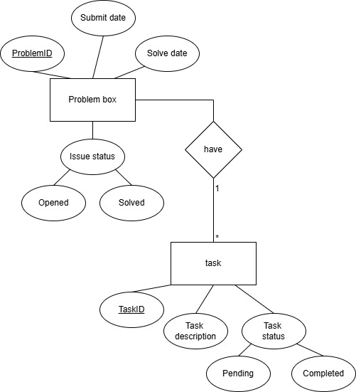

**Fig-6: ER Diagram for Problem box-have -Task**

**Relation**: One to Many

**UNF: 1.** Problem-ID, Submit date, Solve date , opened, solved , Task-ID, task description, pending, completed.

**1NF: 1.**  Problem-ID, task_id, task description, pending, completed

**2.**  Problem-ID, submit date , solve date, opened, solved

**2NF:** **1.** Problem-ID, Task-ID, task description, solve date

**2.** Problem-ID, pending, completed, submit date

**3 .**  Problem-ID, opened, solved

**3NF: 1.** Problem-ID, Task-ID, task description, solved date

**2.**  Problem-ID, submit date

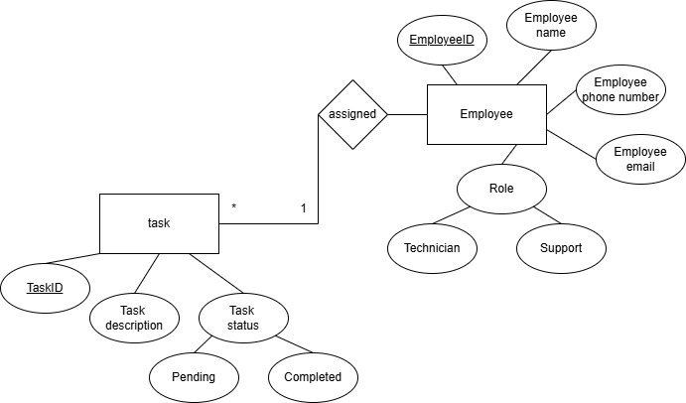**Fig-2: ER Diagram for Task-assigned-Customer**

**Relation**: many to one

**UNF** 1. Task-ID, task discription, pending, completed, E-email, Employee-ID, E-name, E-phone number, technician, support.

**1NF 1.** Task-ID, Employee-ID, E-phonenumber

**2.** Task-ID, task discription, pending, completed

**3.** Employee-ID, ename , email, technical, support

**2NF** **1**. Task-ID, Employee-ID, E-phonenumber

**2.** Task-ID, task description

**3.** Task-ID, pending, completed

**4.** Employee-ID, ename, email, technical, support

**3NF 1.** Task-ID, Employee-ID, E-phonenumber

**2.** Task-ID, task description, ename

# **Finalization**

1. Customer ID, c_Name,
2. City, Country
3. Customer ID, c_phone number , account status, c_Email.
4. customer ID, subscription ID.
5. Subscription-ID , start date,End date.
6. Subscription-ID , status.
7. Subscription_ID, Service-ID .
8. service ID , monthly cost , service type.
9. ~~Customer-ID, C_Phone number .~~
10. Customer-ID, Payment-ID, C_Email.
11. Payment-ID, Payment date, C_Name, Amount.
12. **~~City , country.~~**
13. Payment-ID, credit Card.
14. ~~Customer-ID, C_Phone number.~~
15. ~~City, country.~~
16. Ticket-ID, Create date, C_Email, cName
17. Ticket-ID, Customer-ID, resolved date, Account status.
18. Ticket-ID, Task id, task discription, resolved date
19. Ticket-ID, created date
20. task_id, employee_id, ephonenumber
21. task_id, task description,ename

**Final Table**

1.Customer_ID, C_name

2.city, country

3.Subscription_ID,Customer_ID

4.Customer-ID, CPhonenumber, Account status, C_Email

5.Subscription-ID, Start date, End date

6.Subscription ID, status

7.Subscription-ID, Service ID

8.Service ID,monthly cost, Service type.

9.Customer-ID, Payment-ID,C_Email

10.CName,Payment-ID, payment date, Amount

11.Payment-ID,Credit card

12.Problem-ID,Create date,C_email,C_name

13.Problem-ID,Customer-ID,resolved date, Amount, status

14.Problem-ID,Task ID, Task discription, resolved date

15.Problem-ID, submit date

16.Task ID,Employee-ID,E_phone number

17.Task ID,Task Discription, E_name

# **Table Creation (DDL Operations)**

|  |  |  |
| --- | --- | --- |
| StudentID1: 23-54878-3 Name: Rofiqullah Munna | StudentID3: 23-54875-3 Name: Raisa Chowdhury | |
| StudentID2: 23-54877-3 Name: Abdullah Al Nahian | StudentID4: 23-54899-3 Name: Mst Fabiha Afifa | |
| **CO4**: Creating DML, DDL using Oracle and connection with ODBC/JDBC for existing JAVA application | | |
| **PO-e-2:** Use modern engineering and IT tools for prediction and modeling of complex computer science and engineering problem | | Marks |

**1.CUSTOMER INFO:**

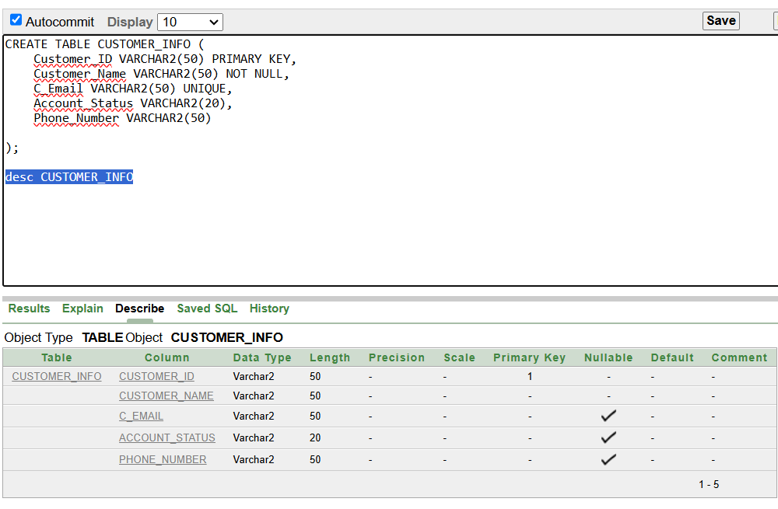

**2.CUSTOMER_LOC:**

**3.SUBSCRIPTION:**

**4.SERVICES:**

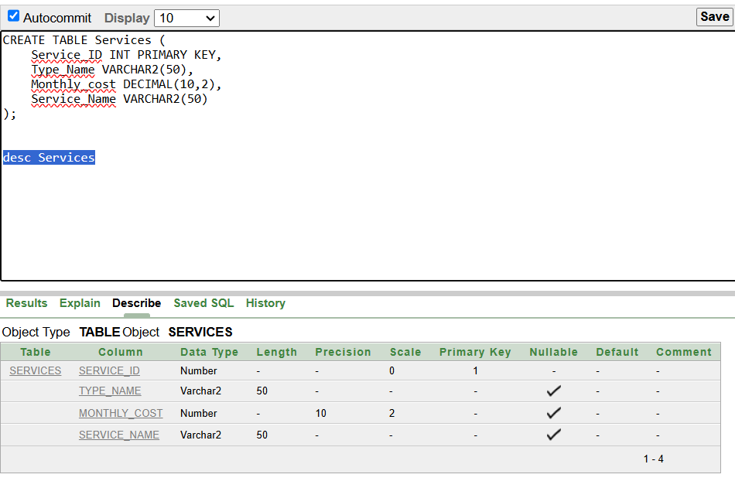

**5. SERVICE_TYPE:**

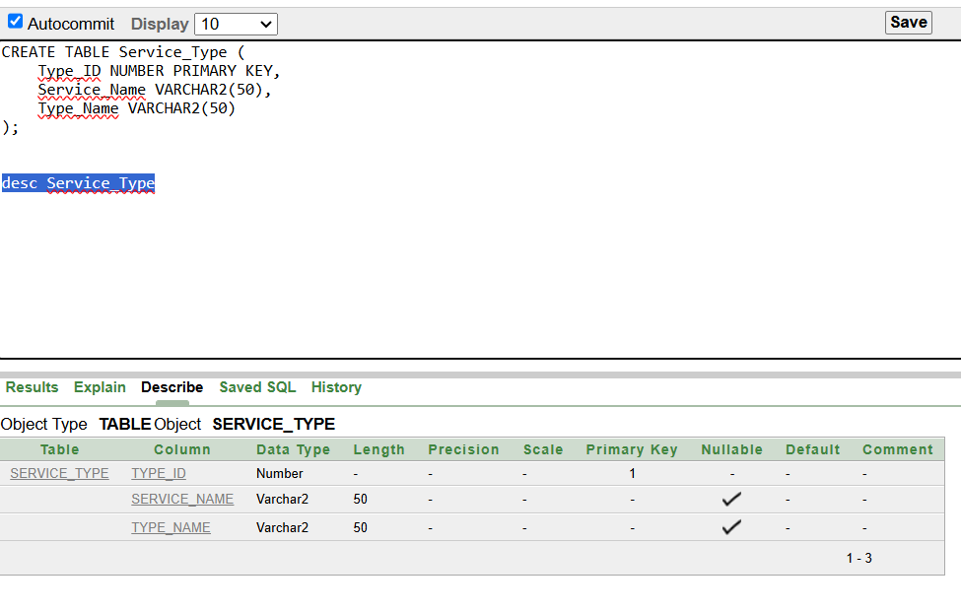

**6.PAYMENTS:**

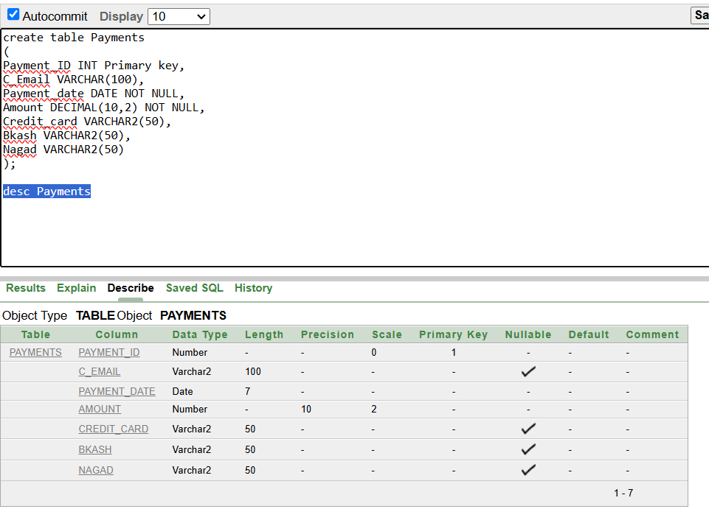

**7.PROBLEM BOX:**

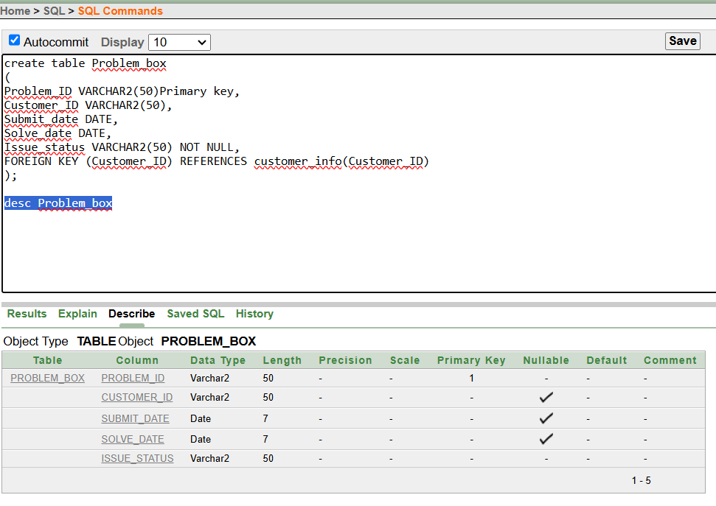

**8.ISSUE_STATUS:**

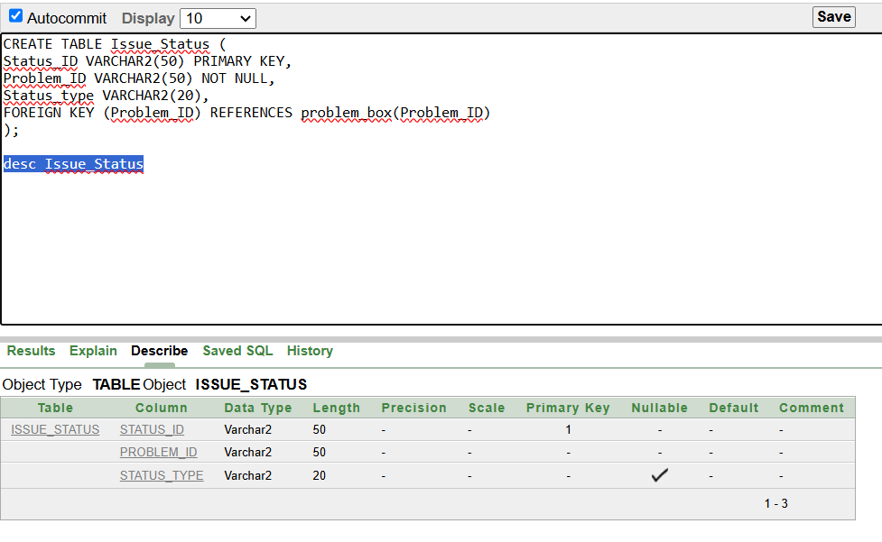

**9.TASKS:**

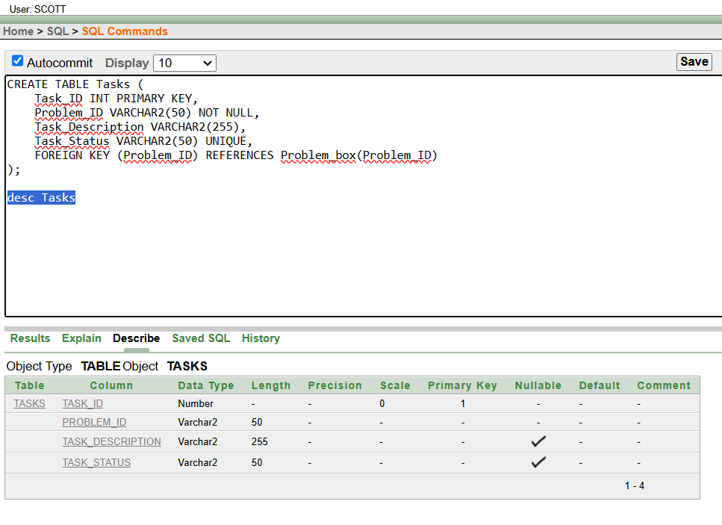

**10.TASK_STATUS:**

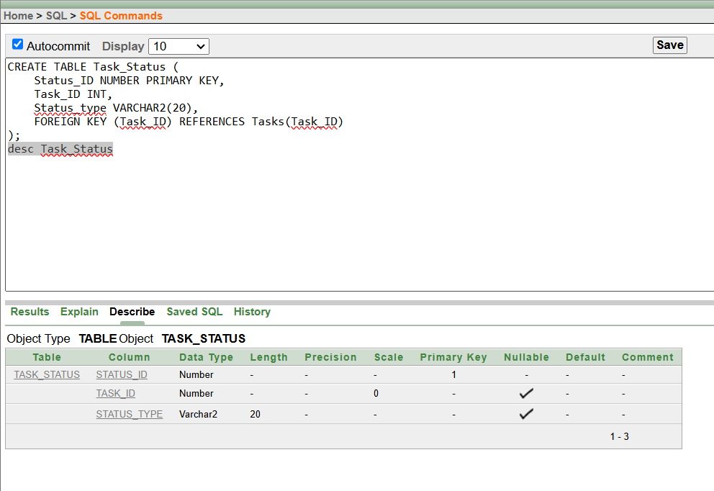

**11.EMPLOYEE:**

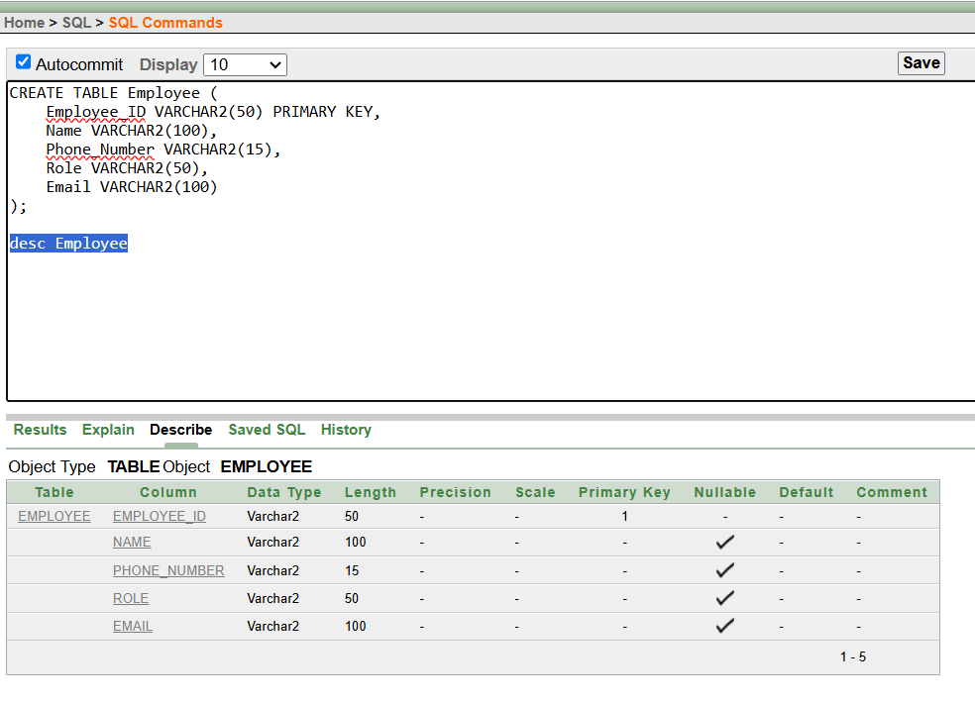

**12.ROLE:**

**13.EMPLOYEE_TASK_STATUS:**

# **Inserted Values in the tables**

**1.Inserting data into CUSTOMER_INFO table**

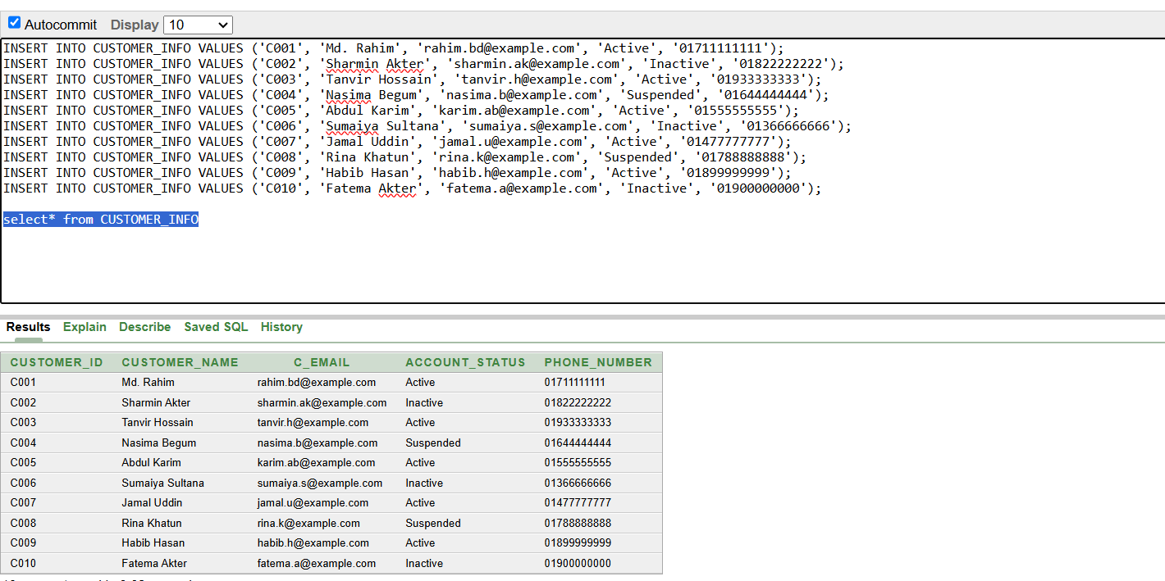

**2.Inserting value for CUSTOMER_LOC**

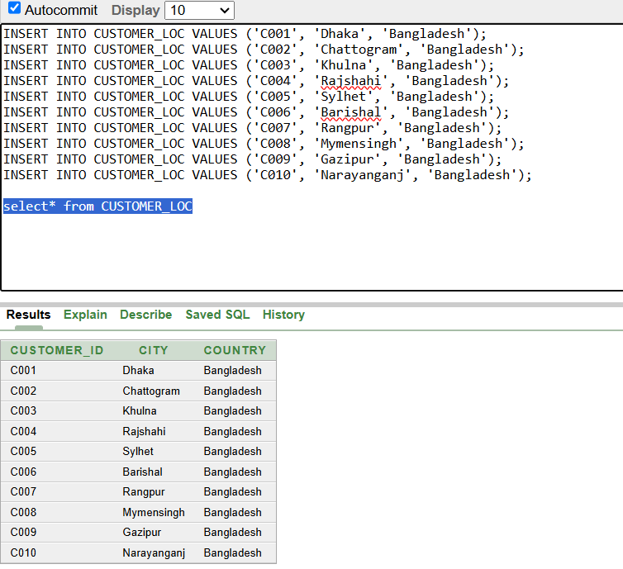

**3.Inserting value for Subscription_info**

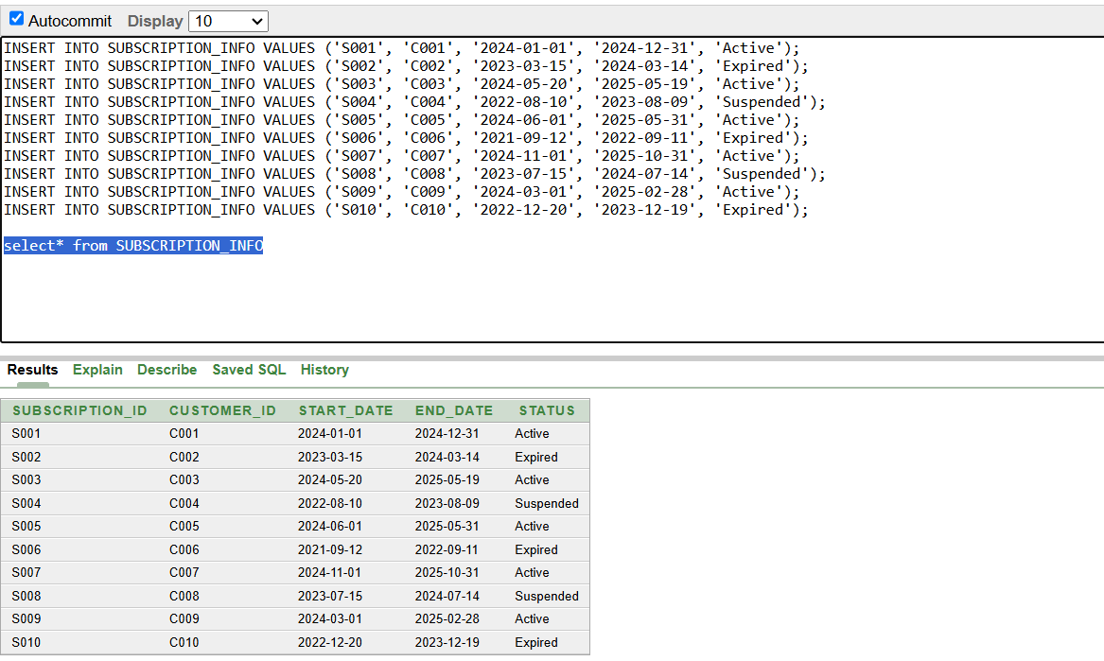

**4. Insert value for Services**

**5. Insert value for Service_type**

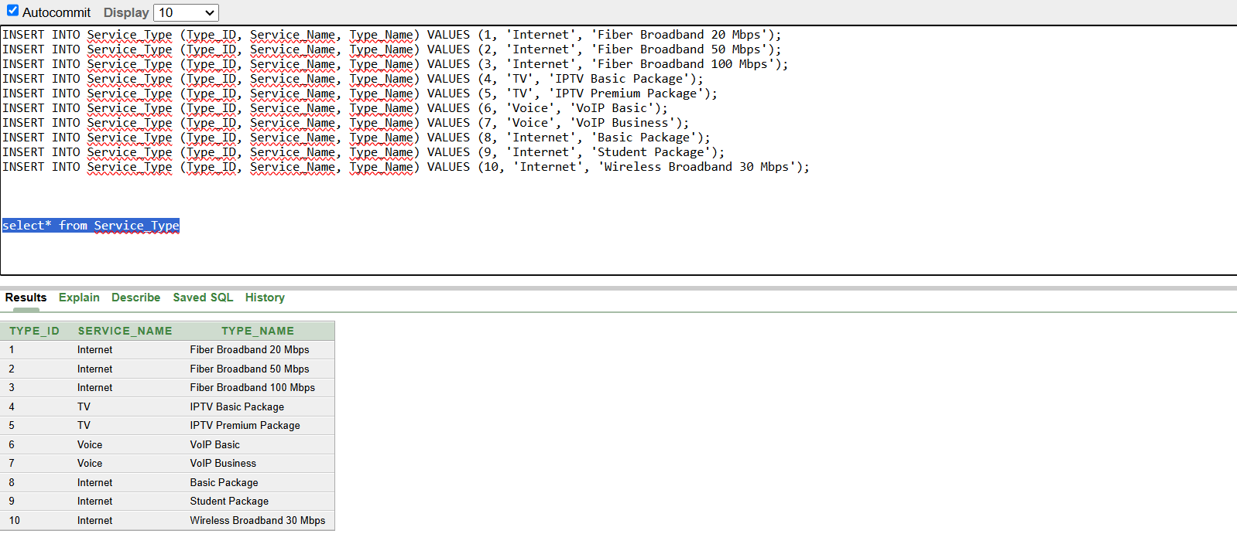

**6. Insert value for Payment**

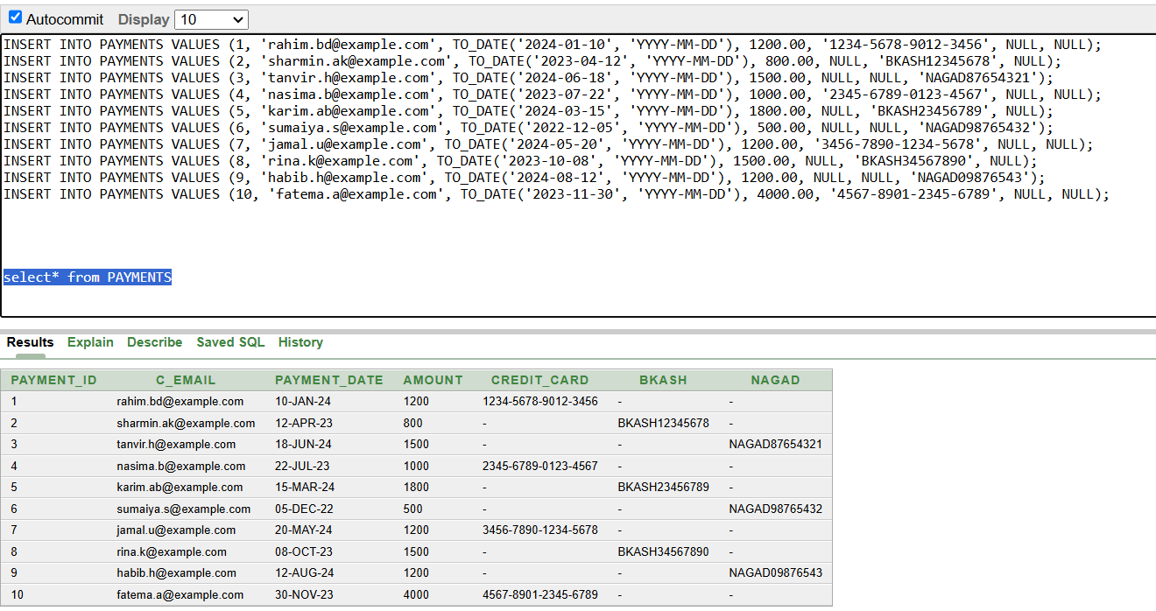

**7. Insert value for Problem_box**

**8. Insert value for Issue_Status  
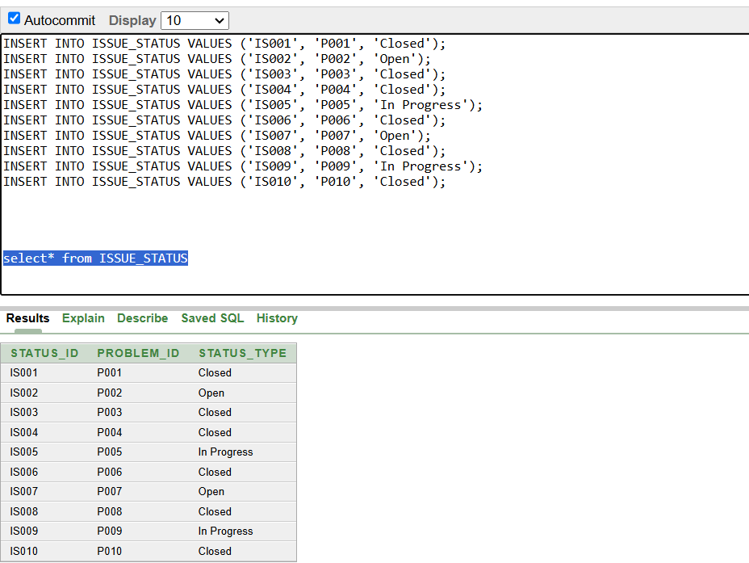**

**9. Insert value for Tasks**

**10. Insert value for Task_Status**

**11. Insert value for Employee**

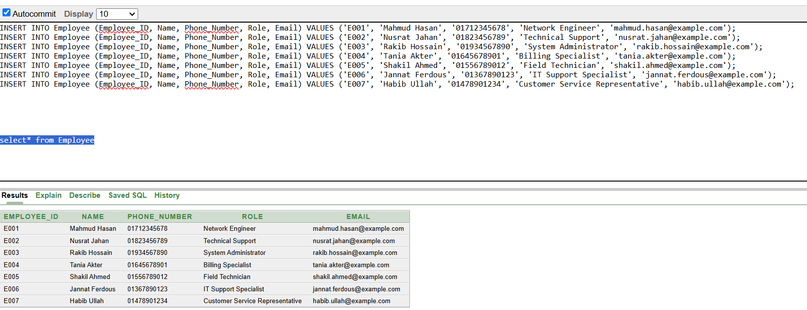

**12. Insert value for Role**

**13.Insert value for Employee task status  
**

# **Query Test in DB**

# **Simple query**

Show all the inforfation of active subscriber

1. **single row function**

**Show all the inforfation of active subscriber:**

1. **aggregate function**

**Query to find the maximum and minimum monthly cost:**

1. **Single Row SubQuery:**

**query to find the information of subscriber that occurs on the latest start date:**

**Find the Email  of customer who made highest payment:**

1. **Multiple Row subquery**

**List of all customers who have made payments above the average payment amount:**

**the names of all customer whose subscription has expired:**

**6.Joining**

**Inner joining:**

**Equijoins Joining:**

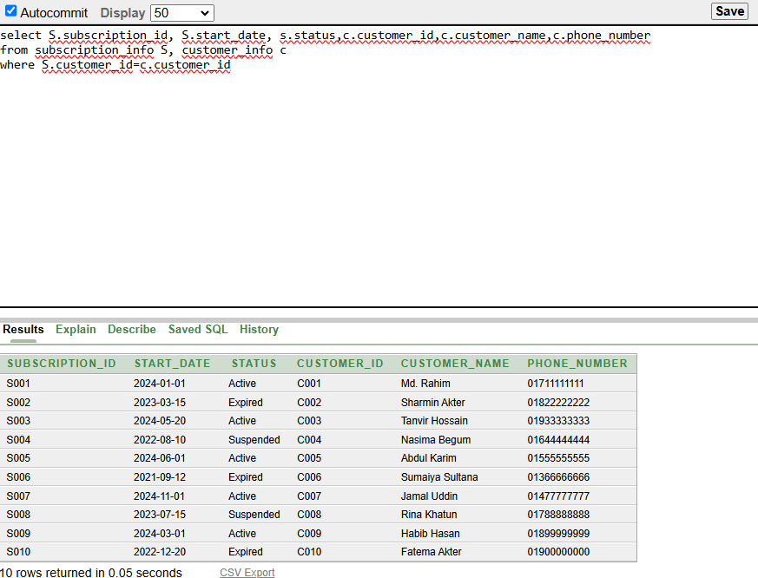

**Non_equijoin**

**Left outer joining:**

**Right outer joining:**

**Outer joining:**

**Simple view:**

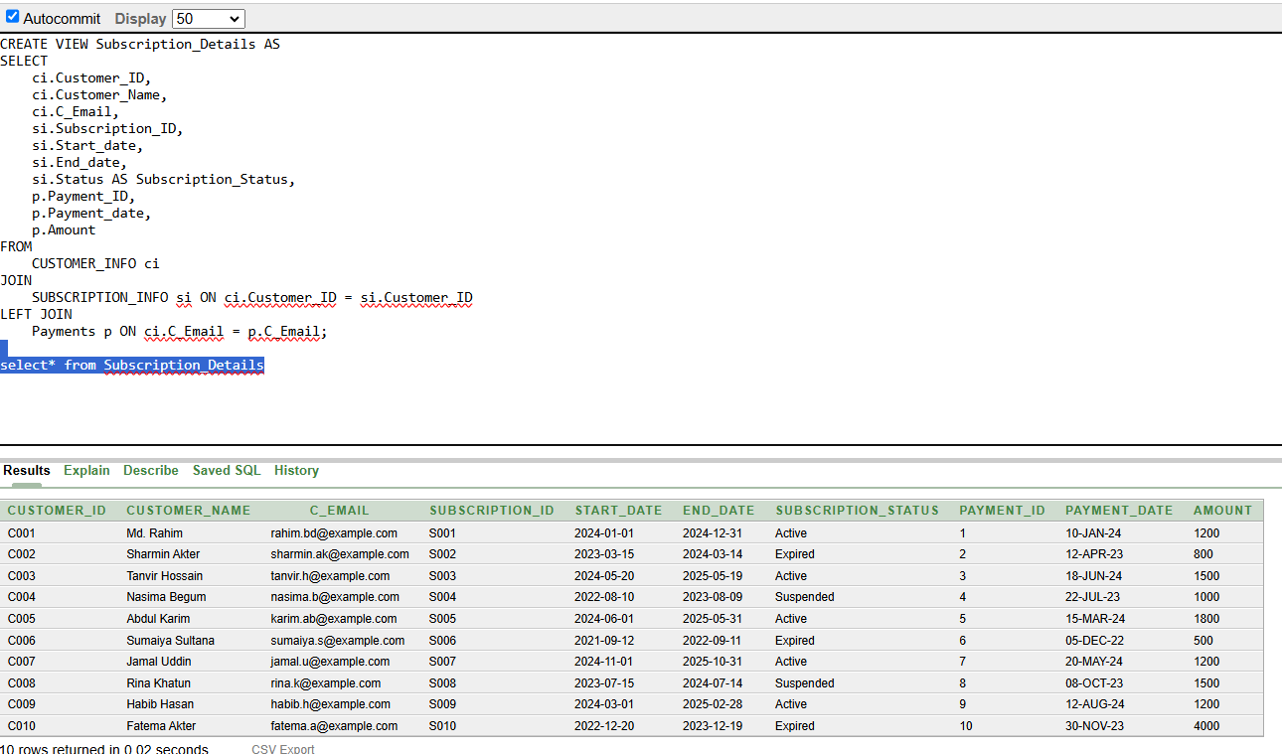**Complex view:**

# **Description of a Successful DB connection**

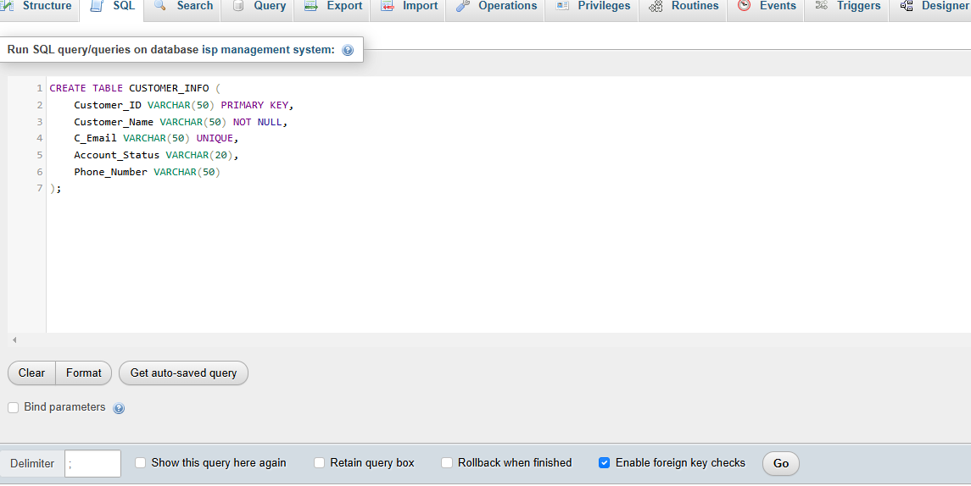

**Create the database and the table**

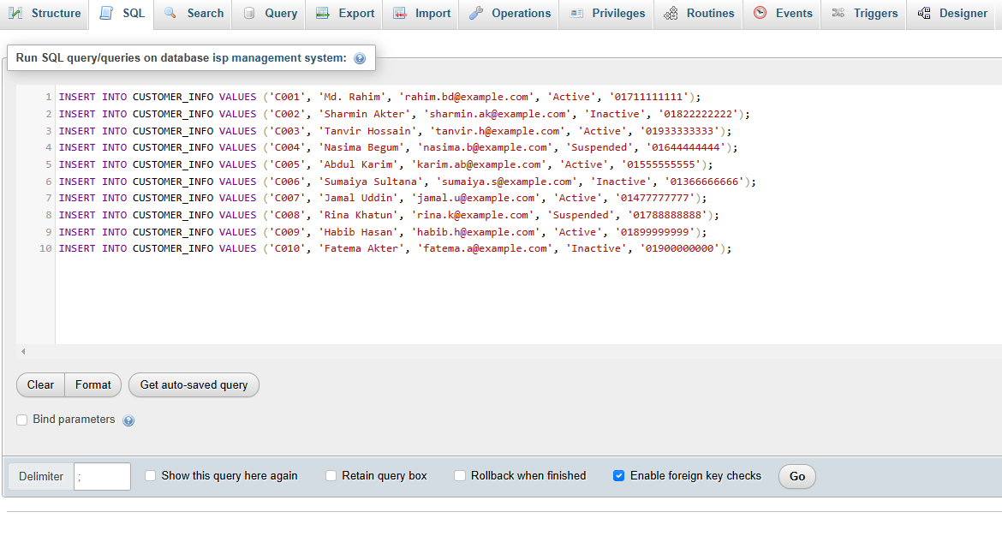

**Insert data into table**

**MySql with java project**

**For Customer_Info table**

**(ID: 23-*-3)**

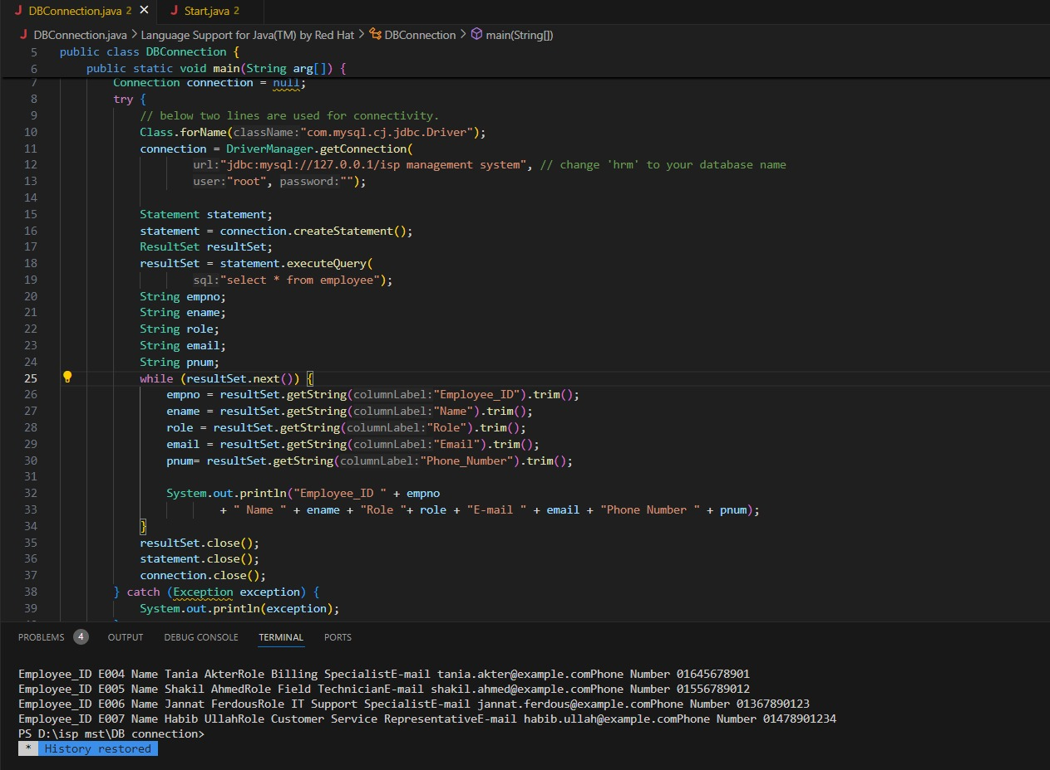**For Employee table**

**(ID: 23-*-3)**

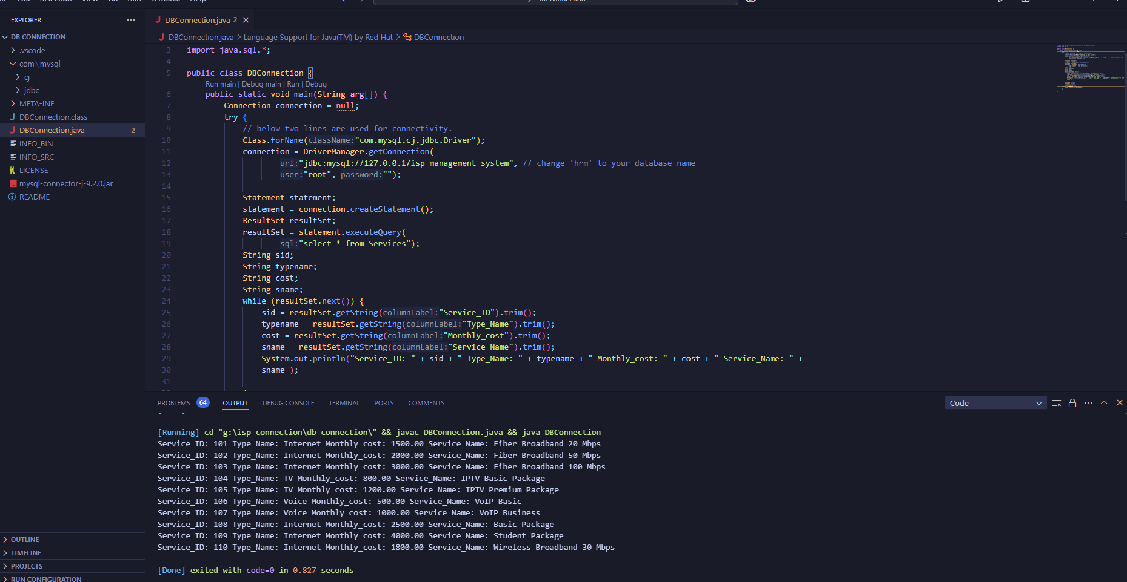**For Services table**

**(ID: 23-*-3)**

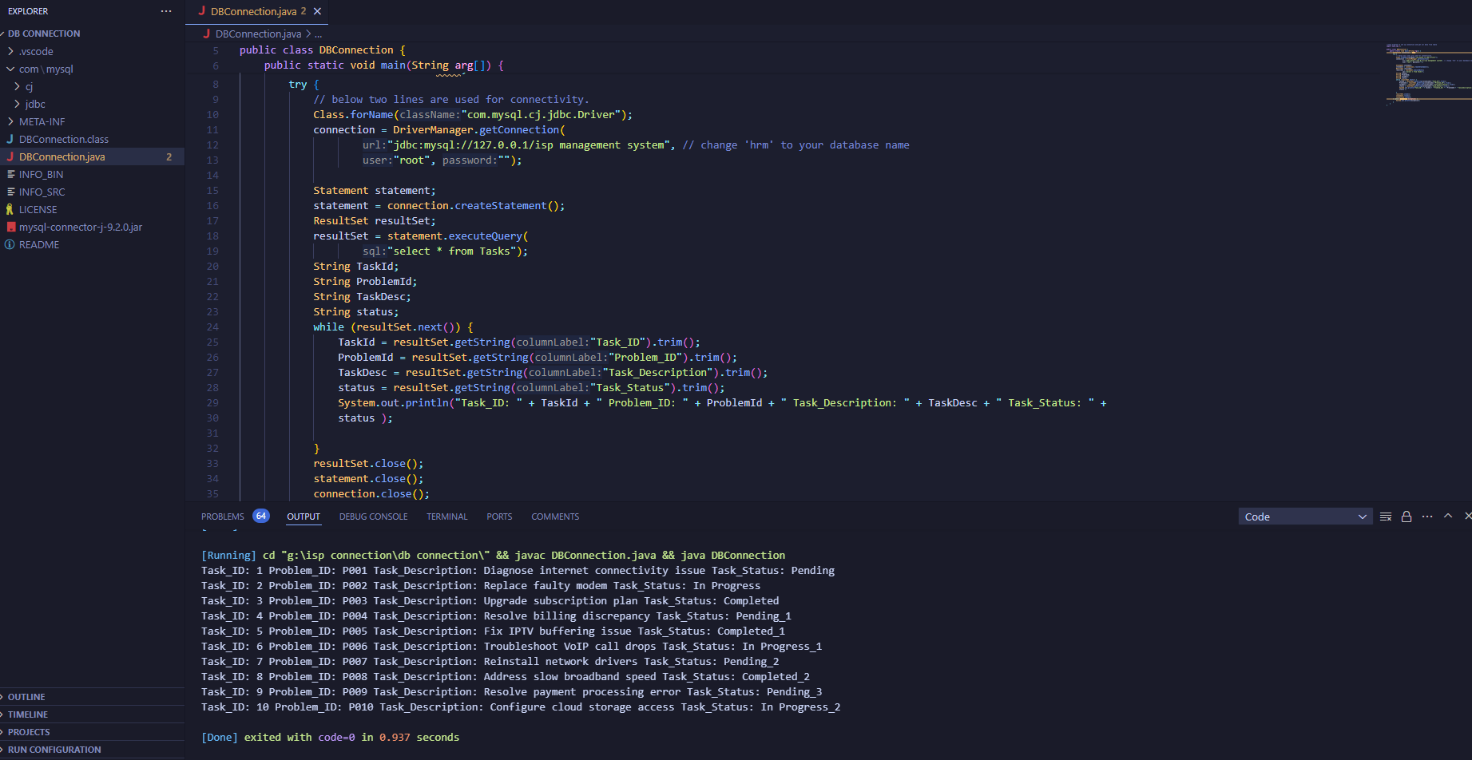**For Tasks table**

**(ID: 23-*-3)**

# **Conclusion**

The Internet Management System efficiently manages users, data plans, and usage logs using MySQL for the database and tools like VS Code for development. Key features include user registration, data plan allocation, billing, and monitoring. The project involves database setup, frontend-backend integration, testing, and local deployment, ensuring reliable and scalable functionality.

### **Future Aspects:**

1. **Cloud Deployment** for scalability and remote access.
2. **Advanced Features** like real-time monitoring and personalized plan recommendations.
3. **Mobile App** for convenient user access.
4. **Enhanced Security** with encryption and role-based access control.
5. **AI Integration** for trend prediction and analytics.
6. **Global Expansion** to support multi-location use and ISPs.

These advancements will make the system more versatile, secure, and user-friendly.